Insert your centre number, name and candidate number into the header above.
Save this evidence document as evidence_ followed by your centre number_ candidate number. For example: evidence_ zz999_9999
Screenshots or program listings must be copied into appropriate cells in the following table.
Examiners must be able to read the contents including any screenshots without the use of a magnifying glass. Answers that are not readable or missing will not be awarded any marks.
Save this evidence document at regular intervals, for example every 10 minutes.
Question 1
Part 1(a)
global FileData
FileData = [[""]*2 for i in range(11)] #string

Part 1(b)
def ReadHighScores():
global FileData
Filename = "HighScore.txt"
try:
File = open(Filename,'r')
for x in range(0,10):
FileData[x][0] = File.readline()[:3]
FileData[x][1] = File.readline().strip()
File.close()
except:
print("Could not read file")

Part 1(c)
def OutputHighScores():
global FileData
for x in range(0,11):
Output = FileData[x][0] + " " + FileData[x][1]
print(Output)

Part 1(d)(i)
ReadHighScores()
OutputHighScores()

Part 1(d)(ii)
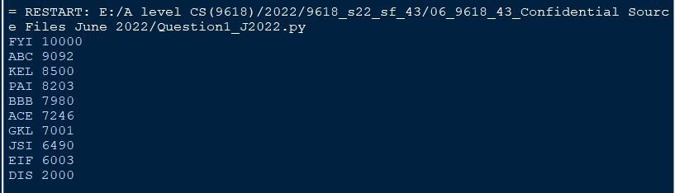

Part 1(e)(i)
Username = "ABCD"
while len(Username) != 3:
Username = input("Enter your Username")

score = -1
while score < 0 or score > 100000:
score = int(input("Enter score"))

Part 1(e)(ii)
def Arrange(Username, Score):
global FileData
for x in range(0,10):
if Score > int(FileData[x][1]):
Temp1 = FileData[x][0]
Temp2 = FileData[x][1]
FileData[x][0] = Username
FileData[x][1] = str(Score)
Count = x + 1
while (Count < 10):
Second1 = FileData[Count][0]
Second2 = FileData[Count][1]
FileData[Count][0] = Temp1
FileData[Count][1] = Temp2
Temp1 = Second1
Temp2 = Second2
Count = Count + 1
break

Part 1(e)(iii)
print("Before")
ReadHighScores()
OutputHighScores()

Username = "ABCD"
while len(Username) != 3:
Username = input("Enter your Username")

score = -1
while score < 0 or score > 100000:
score = int(input("Enter score"))

Arrange(Username, score)
print("After")
OutputHighScores()}

Part 1(e)(iv)
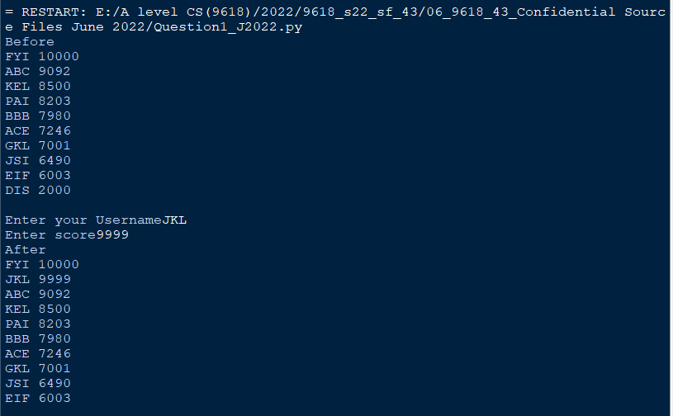

Part 1(f)
def WriteTopTen():
global FileData
Filename = "NewHighScore.txt"
try:
Filename = open(Filename,'w')
for x in range(0,10):
Filename.write(str(FileData[x][0]) + '\n')
Filename.write(str(FileData[x][1]) + '\n')
Filename.close()
except:
print("Could not write to file")

Question 2
Part 2(a)
class Balloon:
#Health as integer
#Colour as string
#DefenceItem as string
def __init__(self, PDefenceItem, PColour):
self.__Health = 100
self.__Colour = PColour
self.__DefenceItem = PDefenceItem

Part 2(b)
def GetDefenceItem(self):
return self.__DefenceItem}

Part 2(c)
def ChangeHealth(self, Change):
self.__Health = self.__Health + Change

Part 2(d)
def CheckHealth(self):
if self.__Health <= 0:
return True
else:
return False

Part 2(e)
Method = input("Enter balloon defence method")
Colour = input("Enter the balloon colour")
Balloon1 = Balloon(Method, Colour)

Part 2(f)
def Defend(MyBalloon):
Strength = int(input("Enter the strength of opponent"))
MyBalloon.ChangeHealth(-Strength)
print("You defended with ", str(MyBalloon.GetDefenceItem()))
if (MyBalloon.CheckHealth() == True):
print("Defence failed")
else:
print("Defence succeeded")
return MyBalloon

Part 2(g)(i)
Balloon1 = Defend(Balloon1)

Part 2(g)(ii)
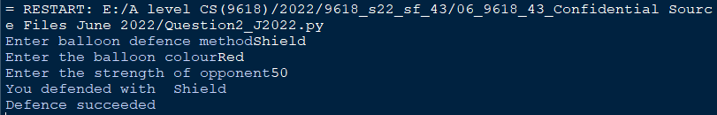

Question 3
Part 3(a)
QueueArray = ['','','','','','','','','',''] #string
HeadPointer = 0 #integer
TailPointer = 0 #integer
NumberItems = 0 #integer

Part 3(b)
def Enqueue(DataToAdd):
global QueueArray
global HeadPointer
global TailPointer
global NumberItems
if NumberItems == 10:
return False
QueueArray[TailPointer] = DataToAdd
if TailPointer >= 9:
TailPointer = 0
else:
TailPointer = TailPointer + 1
NumberItems = NumberItems + 1
return True

Part 3(c)
def Dequeue():
global QueueArray
global HeadPointer
global TailPointer
global NumberItems
if NumberItems == 0:
return "FALSE"
else:
ReturnValue = QueueArray[HeadPointer]
HeadPointer = HeadPointer + 1
if HeadPointer >= 9 :
HeadPointer = 0
NumberItems = NumberItems - 1
return ReturnValue

Part 3(d)(i)
for x in range(0,11):
InputString = input("Enter a string")
ReturnValue = Enqueue(InputString)
if ReturnValue == True:
print("Successful")
else:
print("Unsuccessful")

ReturnValue = Dequeue()
print(ReturnValue)
ReturnValue = Dequeue()
print(ReturnValue)

Part 3(d)(ii)
